Using i-Tree to facilitate capacity training on ecosystem service in the Caribbean.

Presenter: Elvia J. Meléndez-Ackerman (PhD), University of Puerto Rico at Río Piedras

Abstract:
The Ecosystem Services (ES) approach has gained popularity, especially in the last decade in the urban sustainability literature. It has emerged as a revolutionary mechanism to inform stakeholders, planners and decision-makers about the benefits and values associated with blue and green spaces. Even with the increased awareness ES, integrating this vision into public policy has been a challenge. Studies indicate that collaborative efforts lead to the effective co-production and transfer of ecosystem services knowledge. We offer a collaborative model for the generation of ecosystem service information that integrates a suite of tools referred to as i-Tree toolbox. This suite of user-friendly, free software has been developed by the US Forest Service and is widely used in many US cities and internationally. Our collaborative model has generated a network of users and products on urban green spaces through intensive hands-on and one-on-one training on vegetation structure and function and their associated services. The use of i-Tree has greatly facilitated capacity training in this area for a wide diversity of professionals and community members, while at the same time, facilitating the generation of valuable information for land use planning within the context of climate change adaption and biodiversity sustainability.

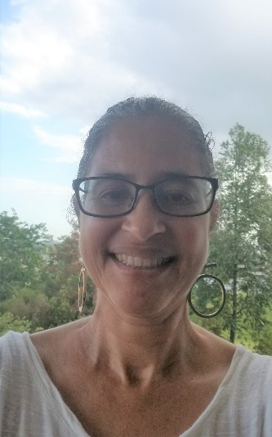
Bio: Elvia Meléndez-Ackerman is a Professor of the Department of Environmental Sciences of the University of Puerto Rico, Río Piedras Campus. She holds a PhD in Ecology and Evolution from the University of California, Irvine and a bachelor's and master's degree in Biology from the University of Puerto Rico, Río Piedras Campus. She is a plant ecologist by training with extensive experience in interdisciplinary work. Over the past 10 years, her research has expanded to address issues related to the sustainability and adaptive capacity of urban socio-ecological systems. In this area he has worked with collaborative teams associated with the San Juan ULTRA (Urban Long-Term Research Areas), the San Juan Urban Field Station both led by the International Institute for Tropical Forestry (IITF). With the support of IITF and funding from NSF-PEER (Partnerships for Enhanced Engagement in Research) and USAID, she served as a main collaborating scientist to the PI in the project “Development and use of the i-Tree tools to explore the potential for urban green infrastructure as an adaption strategy to climate change resilience in the City of Santo Domingo"

Title: Community participation via crowdfunding science: an example of hurricane impact assessments of urban residential yards in Puerto Rico using i-Tree Eco
Presenter: Sofia Olivero-Lora (PhD), Environmental Protection Agency (EPA)

Abstract:
On September 20th 2017, Hurricane Maria struck the island of Puerto Rico removing an estimated 21-31 million trees island-wide using remote sensing techniques. At a local scale, urban forest management following catastrophic storms are better served by forest inventories before and after these events. Here we highlight the role of community engagement to support a science crowdfunding campaign to conduct post-Maria vegetation inventories of residential yards using i-Tree Eco in the city of San Juan. We present some of the results of ecosystem services losses, lessons learned from the experience and areas of opportunity to address local needs to improve the understanding of residential urban forest resources and the ecosystem services that they provide.

Bio:
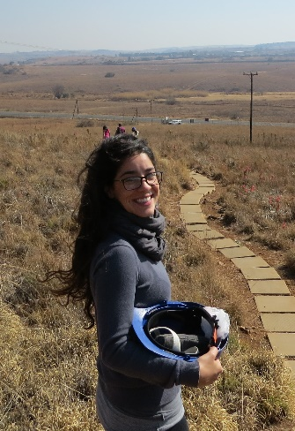
Sofia Olivero Lora She has a bachelor’s degree in Biology with a minor in Ecology and Sustainable Development, a master’s degree in Tropical Forest Management and Biodiversity Conservation and is a recent graduate of the PhD program in Environmental Science from The University of Puerto Rico, Río Piedras Campus. Her published work focuses on areas related to the social-ecological drivers of green infrastructure, sustainability and interdisciplinary work. Sofia currently works as an Environmental Scientist in the Oceans, Wetlands and Streams Protection Branch of the U.S. Environmental Protection Agency in Atlanta, Georgia.

Title: Collaborative Citizen science forest monitoring in El Yunque National Forest, Puerto Rico using i-Tree Eco
Presenter: Christopher Nytch (PhD), Friends of El Yunque Foundation
Abstract:
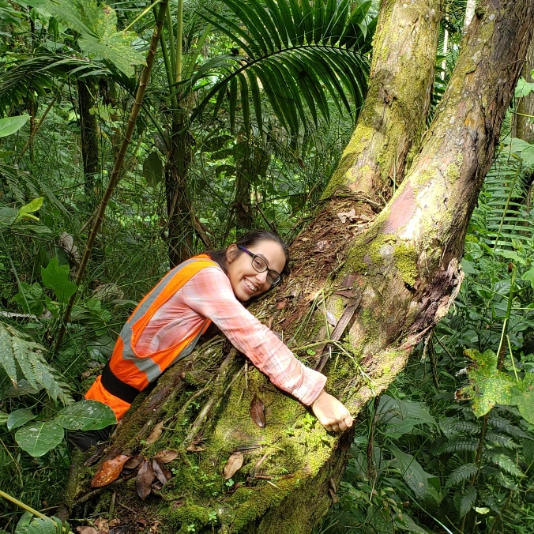
There is growing public interest to contribute to environmental monitoring efforts, and contemporary forest management practices increasingly call for community involvement and educational outreach activities. This presents an opportunity for enhanced participation via citizen science projects that generate multiple outcomes. This talk highlights the El Yunque National Forest (EYNF) Citizen Science Vegetation Monitoring Project, which engages residents of Puerto Rico in monitoring the composition and structure of secondary forest plots. The project showcases a collaborative model consisting of federal, non-profit, academic, and community-based entities. We adapted the i-Tree Eco methodology used in urban settings to accommodate the management priorities of EYNF, as well as the challenging field conditions that predominate in a tropical, post-hurricane environment. Through training workshops and field workdays, we provide hands-on opportunities for citizens and students to learn about and experience the forest in novel ways, while simultaneously adding to the body of knowledge about tropical forest dynamics. Preliminary project results have been incorporated into undergraduate theses and will help inform future management decisions. The data will also be imported into the i-Tree Eco database to perform analyses of ecosystem services regarding forest benefits and connection to human communities.

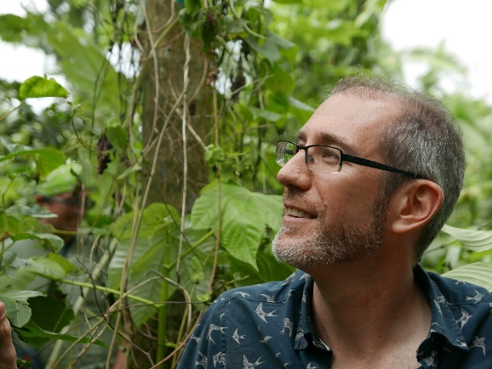
Bio:
Christopher Nytch is an ecologist and educator who lives in Puerto Rico and works in the fields of social-ecological systems, forest ecology, and environmental education. He collaborates with non-profits, governmental, and academic organizations, and local communities to promote conservation stewardship and advance ecological literacy. Chris holds a bachelor’s degree in geology, a master’s in natural resources and ecological planning, and a PhD in environmental sciences. He is a Lead Scientist with the Friends of El Yunque Foundation and directs the El Yunque National Forest Citizen Science Vegetation Monitoring Project. He also coordinates the Puerto Rico Regional Centre of Expertise on Education for Sustainable Development, officially recognized by the United Nations University. Through his work Chris aims to cultivate healthy and regenerative relations between people and place.

